LAB ASSIGNMENT 9.1
NAME:VEMULA RAJEEV KALYAN
HALL TICKET:2403A51324
Task Description #1 (Documentation – Google-Style Docstrings for
Python Functions)

Original Script(without docstrings)
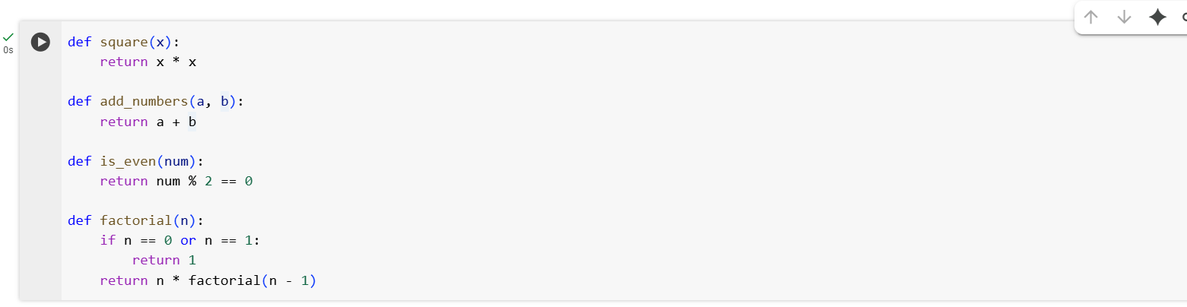 Observation:
- The script defines four fundamental mathematical functions: squaring a number, adding two numbers, checking evenness, and computing factorial recursively.
- Adding Google-style docstrings improves clarity by explaining each function’s purpose, inputs, outputs, and possible errors.
- This makes the script more readable, beginner-friendly, and ready for integration into larger projects or libraries.
- Docstrings also enable tools like Sphinx, IDEs, and linters to generate helpful documentation automatically.
- The use of recursion in factorial is highlighted with an explicit error check for negative values, making the implementation safer and robust.
- Overall, the script demonstrates clean coding practices and provides a strong foundation for learning function documentation in Python.

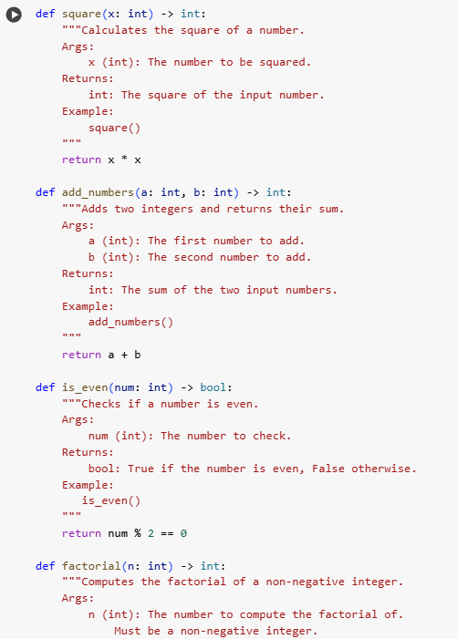
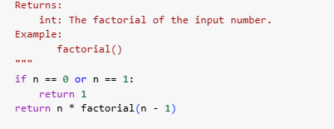

Observation:
- The script now follows Python best practices by including type hints (int, bool) along with Google-style docstrings.
- Each function (square, add_numbers, is_even, factorial) is now self-explanatory, making it easy for both humans and IDEs to understand usage.
- The Examples section in each docstring shows how to call the function, which is helpful for new users and for generating external documentation.
- The factorial function clearly specifies input constraints (non-negative integers), ensuring correctness and avoiding misuse.
- With this structure, the script is production-ready, highly maintainable, and suitable for inclusion in a utility library or educational material.
- Overall, the enhancements make the codebase cleaner, more robust, and professional, bridging the gap between raw code and full documentation.

Task Description #2 (Documentation – Inline Comments for Complex
Logic)

Input Script (no comments):
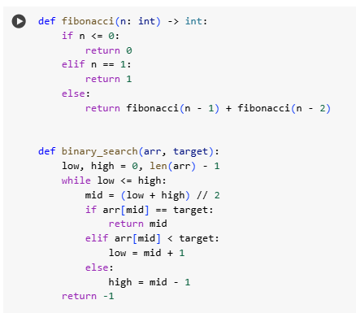

AI Adds Inline Comments (only complex logic parts):

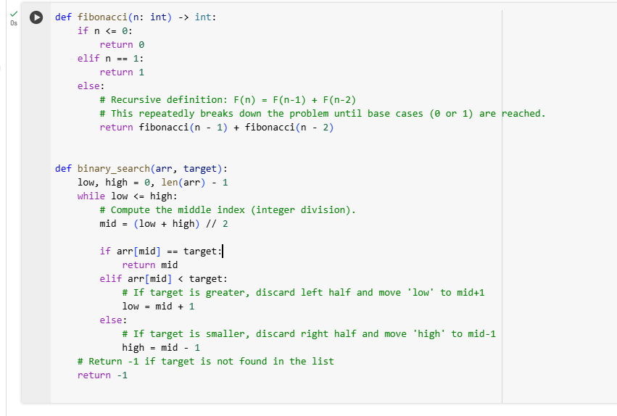 Observation:
- The AI effectively ignored obvious syntax (like simple return statements or assignments) and added comments only to the non-trivial logic parts.
- In the fibonacci function, recursion was explained with base cases vs recursive calls, which clarifies the function’s working for maintainers.
- In the binary_search function, AI highlighted the search space reduction logic (moving low and high), which is the trickiest part to understand.
- The added comments improve readability and maintainability, making it easier for new developers or learners to follow the flow of the algorithm.
- Overall, this approach prevents comment clutter while still ensuring that the complex reasoning behind the code is documented clearly.

Task Description #3 (Documentation – Module-Level Documentation):

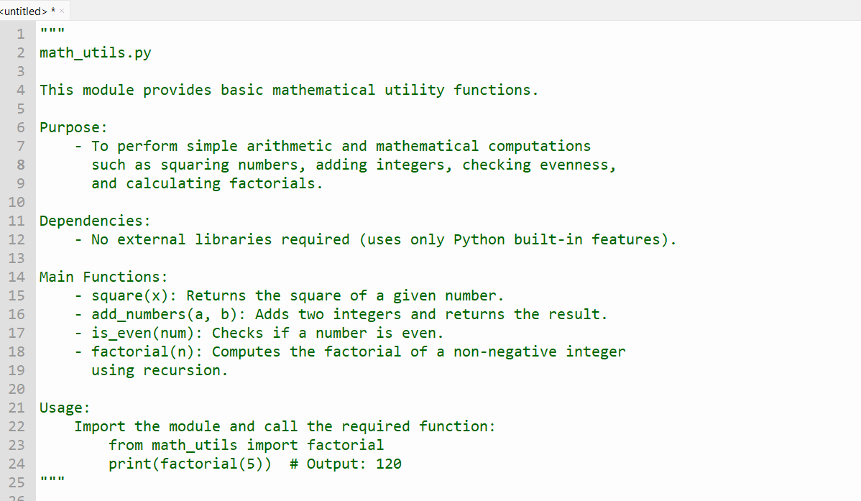
Python File Link:
https://drive.google.com/file/d/173NBW4cUZpr6vDYIY4A8Kch9FJqB1OZa/view?usp=sharing
Observation:
- Summarizes the purpose of the file.
- Lists dependencies (none).
- Outlines the main functions.
- Provides a simple usage example.
This improves clarity, maintainability, and usability without rewriting the code.

Task Description #4 (Documentation – Convert Comments to
Structured Docstrings)
Task Description #4 (Documentation – Convert Comments to Structured Docstrings)
- Task: Use AI to transform existing inline comments into structured function docstrings following Google style.
Original code:
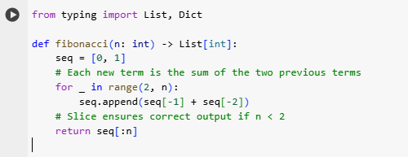
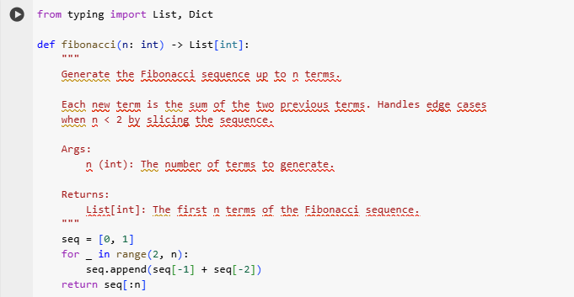
Observation:
Turning the comments into docstrings made the code is cleaner and easier to read. Now the purpose and details of each function are right at the top, so you don’t have to dig through the code to understand it. It feels more beginner-friendly and organized

Task Description #5 (Documentation – Review and Correct
Docstrings)

Python Code (with incorrect docstrings):
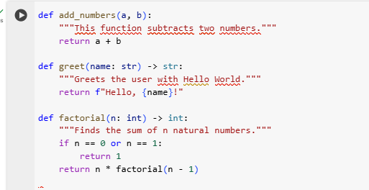
Corrected Version (Google-style Docstrings):
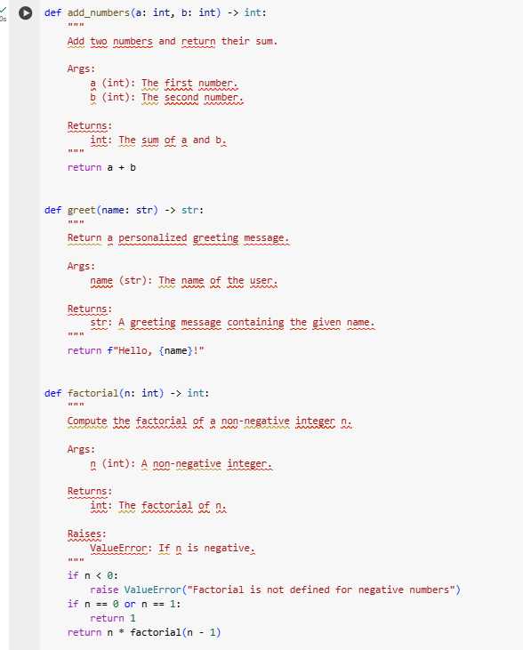

Observation:
In this task, the original code had outdated and misleading docstrings that did not match the actual behavior of the functions. By reviewing and rewriting them in Google-style format, the documentation became clear, consistent, and accurate. This ensures that future users or developers can easily understand the purpose, arguments, return values, and possible errors of each function, improving both readability and maintainability.

Task Description #6 (Documentation – Prompt Comparison
Experiment)
Python Function:
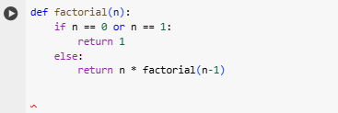
Vague Prompt: “Add comments to this function”:
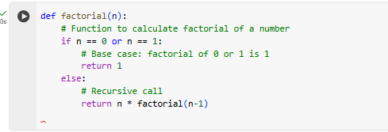
Detailed Prompt:
“Add Google-style docstrings with parameters, return types, and examples”
AI Output:
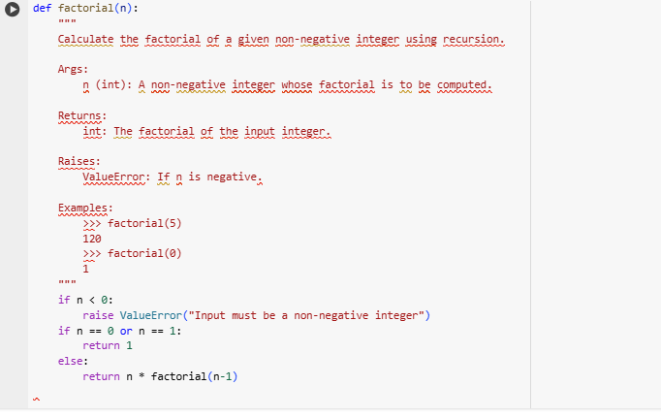
Observation for Detailed Prompt:
The detailed prompt produced a Google-style docstring that is structured, clear, and highly informative. It specifies parameters, return values, exceptions, and usage examples, making the function easy to understand and reuse. Compared to vague comments, this approach ensures accuracy, completeness, and professional documentation quality.
The detailed prompt generated a well-structured Google-style docstring that captures every aspect of the function. It not only describes the purpose of the function but also explains inputs, outputs, and possible errors. The addition of examples makes the function easier to test and understand for beginners. Compared to simple inline comments, this documentation style significantly improves readability, maintainability, and professional standards. Such detailed docstrings are especially useful in large projects, collaborative environments, and API documentation, where clarity and precision are essential.

